Office 365 and Microsoft TEAMS

All of our weekly home learning/homework will be set through TEAMS. Should any child be unable to attend school due to illness or a lockdown situation then we will be using TEAMS to ensure that the children have access to their learning and that they have communication with their teacher.

Your child’s login will be made up of a username and a password.

In most cases, the username will be your child’s initial and surname followed by @stswithuns3423.onmicrosoft.com and their password will be their initial and surname.

If you are using a laptop/PC
- Go to www.office.com
- Click Sign in
- The username is your child’s email address as stated above
- Then click Next
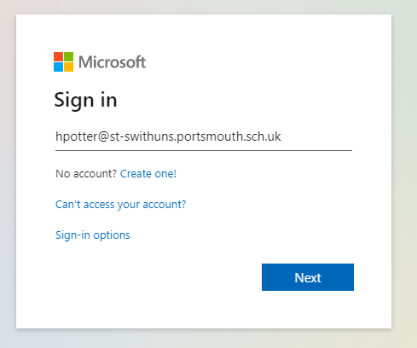
- Enter the password asstated above
- You should then see this screen:

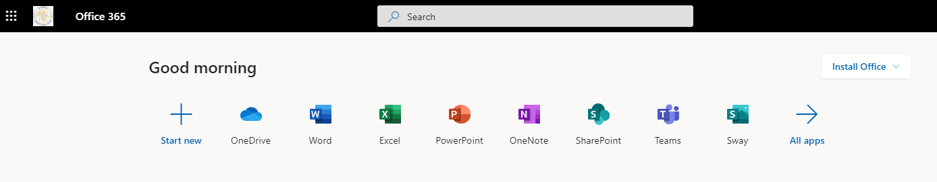
- Click on the Teams icon and this will take you to teams
- You should now be able to see the Teams that you are part of – your child’s class
- If it asks you to download the app to your computer, we do advise it as it seems to work better

If you are using a tablet
- You will need to download the Teams app to your device
- Then log in using the same log in details as above
- You can then access your class team

Homework
We will be using TEAMS for all homework. When your child logs into Teams, they will see a screen that looks similar to this. If the children have any homework, the assignments icon will have a red button on it.
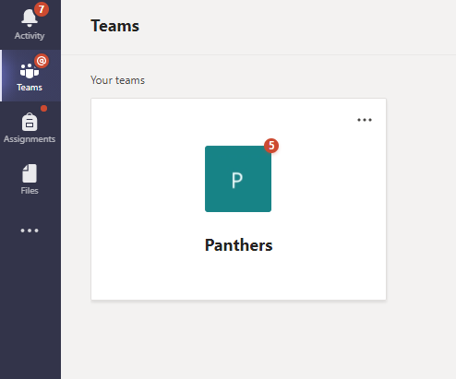

The children need to click on this and it will take them to their class and then they can access any home learning activities they have been assigned.
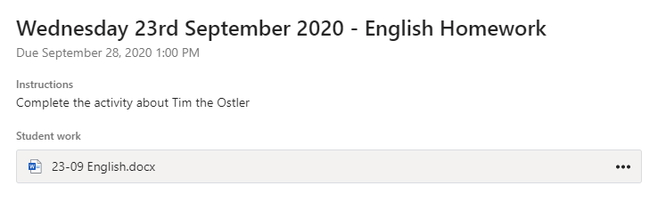
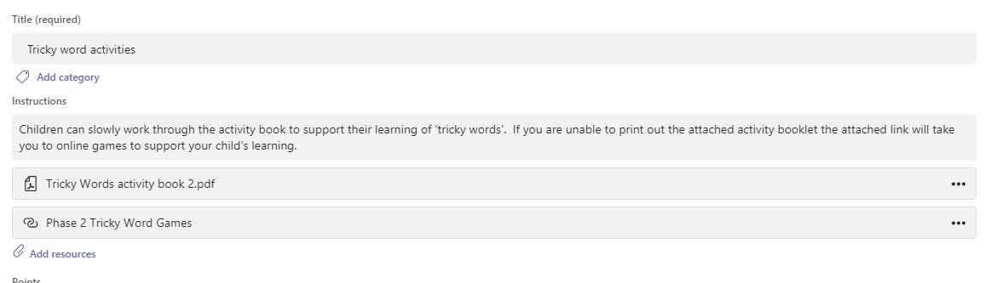

If the children have to complete a task using Word, they open the task, complete it then close and turn in. There is no need to save it as it automatically saves itself.

Early Years & Sunbeams
There may not always be a worksheet to complete, it may just be looking at a video online or practising your times tables or phonics using a website, but all home learning will be given to the children through TEAMS.

If you have any questions at all, or difficulties logging in, please call the school office on 02392.829339.

