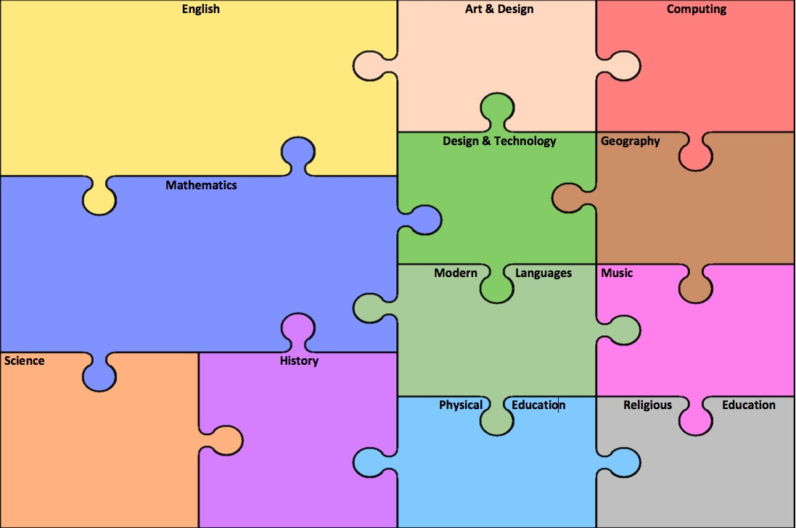

We will have a focus on Geography this half term.

In French we will be learning how to introduce ourselves to others and have basic conversations using greetings. We will also learn to say how we are feeling and how to ask others how they are.

Our focus for this half term is rhythm. We will be using the percussion instruments to play, compose and then notate sound patterns. These skills will then be used to accompany a variety of songs.

We will have a focus on Design and Technology this half term.

**Text, videos, music, pictures to ensure experiences of** r**ich and varied literary heritage**

Children will be looking at texts related to our topic, including different versions of the traditional tales including The Three Little Pigs.

**Exciting beginnings / events/ theme days/ trips / visitors**

We will be walking around our local area. observing the human and physical features.

**Reading** –

To begin the year, we will be reading and sharing traditional tales and some adaptations of these, such as The Three Little Pigs. We will be using our phonics to sound out unfamiliar words and phrases to support our reading and recognising known common exceptions words within a text.

**Writing** –

We will be writing simple sentences linked to the text The Three Little Pigs, particularly focussing on our cursive handwriting to set the standard for the year.

**Grammar** –

We will be focusing on key punctuation, including capital letters and full stops and we will begin to read through our sentences to check they make sense.

**Speaking and Listening** –

We will explore these texts through speaking, listening and role play, paying particular attention to repetitive phrases and the use of expression and intonation.

**Spelling**

We will be using our phonic knowledge to help us spell more accurately.

A geography walk around our local area.

Creating E-safety posters.

During this half term we will be reading the creation story and understanding how God created the world around us. We will be reading and singing psalms. We will write our own psalms and creation prayers.

We will be focusing on developing our co-ordination and balance through a variety of activities, songs, stories and skill based games.

In games we will be improving our sending and receiving skills using a range of equipment and learning to work co-operatively.

We will have an exciting opportunity to design, create and evaluate our very house for the Three Little Pigs. We will need to use our fine motor skills and a range of suitable equipment.

This term we will be learning about everyday materials and identifying what different objects are made from. On our local geography walk, we will make links to a variety of materials and begin to understand their purposes.

We will have the opportunity to gather materials around the school and investigate which material would make the most effective house for The Three Little Pigs.

**PSHE / British Values**

Through all areas of the curriculum and the ethos of the school we are developing a sense of community, respect, belief and responsibility for ourselves and others. We will learn a sense of law by writing our own class rules which pupils take responsibility for and agree to abide by.

We will use simple fieldwork and observational skills to study the geography of our school and its grounds. Throughout these lessons we will encourage the children to use basic geographical language and understand the difference between human and physical features.

This half term we will become more aware of the importance of online safety. We will discover ways of remaining safe whilst using the internet.

***As in previous years we will not have set maths groups, they will be fluid groupings to enable children to be extended or supported, depending on their current needs on a day to day basis.***

We will be focusing on recognising numbers and their values using concrete and pictorial resources to help us. Using a range of mathematical apparatus, we will develop our ability to write and solve simple number sentences accurately. We will be reading, writing and ordering numbers up to and beyond 100. We will also be encouraging reasoning to support and challenge their mathematical thinking.

**St. Swithun’s: Year Curriculum Map – Autumn 1. Topic: Twisted Tales**