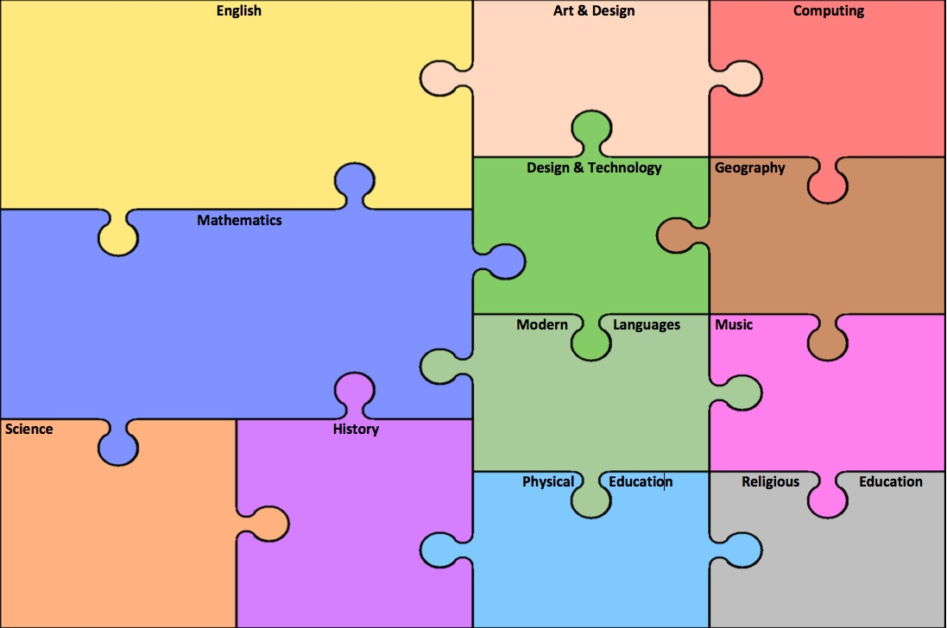

We will begin the year thinking how music enhances our lives. Then, we will link in to the class topic themes, discovering how suspense is created in music and composing and playing music for a fairground ride.

In French we are learning how to talk about our school building and school subjects. We will learn opinions and how to give reasons for them

**Exciting beginnings / events/ theme days/ trips / visitors**

Model making

Visit to southsea funfair

***Major outcomes for the topic:***

***Fairground ride model***

***Spooky Story***

**Reading and Writing**

In literacy we will be consolidating our basic understanding of grammar and sentence structure and writing short stories around the growth mindest characters for our KS1 and Early Years classes. We will then be reading and analysing a range of short spooky stories, making predictions and justifying our answers using evidence from the text. We will then apply what we have learnt and strategies the authors have used into our creating our own spooky narrative. We will include features such as figurative language, a variety of sentence structures and descriptive features to keep our reader engaged.

**Grammar**

We will be using a range of clause structures in our writing and learning about how to create effective expanded noun phrases for detail. We will also be using brackets, dashes and commas for parenthesis.

During Science we will be learning about electricity. We will investigate how electricity can be conducted and how circuits and the components within them work. We will be applying our understanding of this by creating wire loop games, burglar alarms as well as using causal language to explain why different circuits will – or won’t – work!

In maths this half term we will be reviewing our understanding of place value and extending it to focus on the value of numbers up to 1 million as well as decimals. We will also work on rounding numbers to the nearer 10, 100, 1000 and 100000. We will be reviewing the four operations, ensuring we fully understand the concepts, through the use of concrete resources and pictorial representations. As well as becoming more fluent in solving calculations, we will continue to apply our understanding to a wide range or problem solving and reasoning tasks. Finally, we will continue to work on our mental maths, ensuring we fully embed our strategies as well as learning new ones.

**PSHE / British Values**

This half term we will be learning about cooperation and team work. We will be exploring our talents and thinking about positive role models in the world around us.

In creation we will be revising our school mission statement and it’s meaning. We will also be recapping creation stories and reminding ourselves of God’s gifts to us. We will also be focussing on how we can be more effective stewards of God’s creation.

In DT we will be designing and creating our own fairground ride models within small groups. We will learn to measure and cut accurately and we will connect pieces together using the correct equipment. This will then be connected to a motor and the computer programme which will allow the models to rotate.

In computing we will be exploring the internet. We will find out how the internet works and remind ourselves about the importance of managing what we share online.

None this half term

In PE we will be rehearsing our Gym Skills so we can perform a range of rolls and balances correctly as well as likning them into smooth, controlled sequences. In games we will learn the basic skills of Netball then use this to develop our attacking and defending tactics. Y6 will also be having their swimming lessons.

None this half term

We will learn a little about the history of the fun fair and how they have become so popular throughout the world.

**Text, videos, music, pictures to ensure experiences of** r**ich and varied literary heritage**

**St. Swithun’s: Year 5/6 Curriculum Map – Autumn 1. Topic: Thriller**