Extended Day

Before and After School Care



Parent and School Partnership

Handbook September 2026

Before School Care Fees
Sunlight Morning session (E) from 7.30 am to 8.00 am  Light breakfast provided by 7.50 am | £2.25
Sunlight Morning session (M) from 8 am – 8.45 am  No food provided | £3.40
After School Care Fees
Twilight Afternoon session (A) from 3.30 pm – 4.30 pm  A small fruit snack is served after school | £5.15
Twilight Afternoon session (L) from 4.30 pm – 5.45 pm  A light tea is served around 5 pm | £4.60

Cancellations
Bookings can be cancelled online up to midnight 48 hours prior to the session date. Failure to do so will incur full fee payment.

Routines - Before School Care
- When a child is dropped off at Before School Care, the adult must sign their child in and record their child’s arrival time
- If a child is arriving between 7.30 am and 8 am, a light breakfast will be served
- All children are able to choose from a range of activities
- At the end of after school care Early Years’ and Key Stage 1 children are taken to their playgrounds by a member of staff
- Key Stage 2 children make their own way to their playground

Routines - After School Care
- Early Years’ and Key Stage 1 children are collected from class by a staff member and escorted to after school care
- Key Stage 2 children make their own way to after school care
- All children are registered by staff upon their arrival in after school care after which the children have a snack, before choosing from a range of activities
- A more substantial snack is served at approximately 5 pm

Collection from After School Care
- A member of staff will greet the child’s responsible adult and call the child to collect their belongings. The child MUST be signed out by their responsible adult with a record of the time they are leaving
- Staff cannot allow children to be collected by someone unknown to them unless that person is able to give the agreed designated password.
- If there were any doubts about the collection arrangements, the child’s parents would be contacted.
- If the parent/carer is running late, they must call the Extended Day Team mobile on 07419.829478 stating the child/ren’s name(s) and the new arrangements for collection. Please note extended day closes at 5.45 pm
- If a child is not collected, staff will make several attempts to contact the parent, carer or designated adult; failure to make contact will result in the After School Care leader calling the Head Teacher or Deputy Head Teacher, social services may also be called

Content of the Care
There are a variety of activities each morning including painting, construction, craft, games and reading. Children help to clear away the activities.

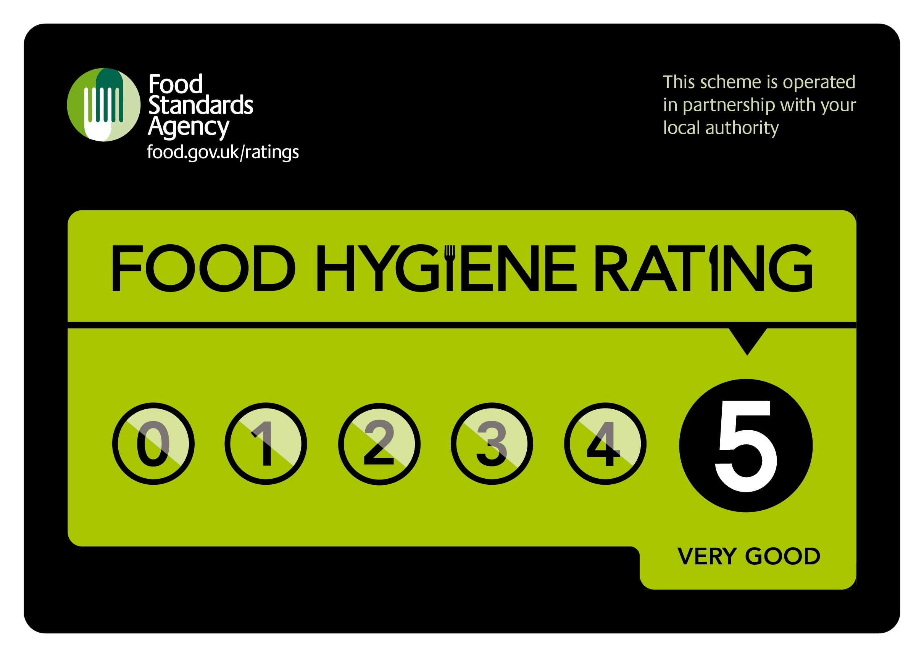
Snacks and Food
We have retained our Food Hygiene Rating of 5 Stars and all food is prepared in accordance with food standards. Children have access to water at all times.
- An example breakfast will comprise: toast, brioche with water to drink
- A light snack will be served at approximately 3.45 pm
- 5 pm approximately a more substantial snack will be served
- Where possible children will help to prepare food and clear away afterwards
- Children are taught about hygiene, are asked to wash their hands before sitting down at the table, expected to respect others, share food, pass items to one another, eat politely and encouraged to have a small taste of the foods they may not have eaten before

Food Allergies
If a child has a diagnosed food allergy, it is the responsibility of the parent/carer to provide the Extended Day Team with a comprehensive list of food items that can and cannot be eaten by their child. Any information about food allergies or special dietary requirements must be stated via email before booking. Staff will cater for allergies or special dietary requirements where possible. Children are not permitted to eat their own snacks.

First Aid
Several members of the team are fully trained in paediatric first aid. The procedure for dealing with an accident, illness or injury is the same as in the school and the children are familiar with the system. There is a first aid box. The accident will be recorded for the parent(s) to see in accordance with the school procedures. If it is a more severe accident, emergency contacts will be called.

Medicines
If a child has a diagnosed specific medical need, e.g. EpiPen, inhaler and/or other prescribed medicines, it is the responsibility of the parent/carer to provide Extended Day Team with a complete set of medicines, in addition to those held in the School Office. If the medicine is for short-term use only, the parent must fill in a medicines form available from the Extended Day Team.

Special Needs
We believe all children have the right to share in the Extended Day Care environment and activities. We will do our best to accommodate all children within our group. However, we cannot guarantee to be able to offer a place to all our pupils.

Behaviour
Before and After School Care operates in conjunction with the relevant policies from St. Swithun’s Primary School. In order to enable the children to become responsible and caring members of the community, we:
- Act as positive role models
- Promote good manners
- Encourage respect for self, others, and property
- Instil self-discipline
- Develop opportunities for children to have a voice

Payment
We accept payment using:
- Childcare Vouchers Help paying for childcare: Childcare vouchers and other employer schemes - GOV.UK
- Taxfree Childcare Tax-Free Childcare - GOV.UK
- Student Finance England Childcare Grant Childcare Grant: Overview - GOV.UK
- We will produce statements for you to claim back charges via Universal Credit Universal Credit childcare costs - GOV.UK
- You can also pay online, via your SCOPAY account

Penalty Charges
The fine for late collection after 5.45 pm is £18.75 per child; this is in addition to the standard session charge. If you frequently collect your child late, we will issue a warning and should this occur more than three times, a fine of £20 per child will be applied, and you risk losing your place on Extended Day Care.

Communication
Parents must make sure staff have information about variations in collection routines whenever possible:
Calling between 8 am - 3.30 pm | Call School Office on 023.9282.9339
Calling between 3.30 pm - 8 am | Call After School Care on 07419.829478 stating full names of all children
Email | correspondence@sscps.co.uk  This is monitored during school hours term time only
In the event of a child not arriving when they are due to attend an After School Care session, a member of staff would be informed and school procedures will be followed.

Complaints
Our aim is to provide an outstanding service for your child. However, should there be any problems that arise, please speak in the first instance to a member of the Extended Day Care staff. If you wish to take it further, we can then advise you on how to follow the school’s complaints procedure.

Our Team

Sarah Hankin-Gould, Supervisor

I joined the Extended Day team in September 2019. I have lots of experience working in schools, primarily as a TA within early years, and I can be found in the Bumblebee class during the day. I have also run successful 'out of hours' and holiday clubs for children aged 2 - 11. I enjoy helping children to learn and grow, and knowing that no two days are ever the same! When I'm not at work I enjoy spending time with friends and family, reading and running.

Lubova Sabir

I am originally from Latvia and have been in Portsmouth since 2007. I am paediatric first aid trained and have a degree in Business Management and speak Russian, Latvian and English. My interests are gardening, cookery, reading and sport and love working in Extended Day Care. I also work as a lunchtime assistant, which is always a busy time helping to organise games and activities. I get to meet lots of children throughout the day!

Bev Calvert

Thank you for choosing Before and After School Care. We look forward to welcoming your child.

